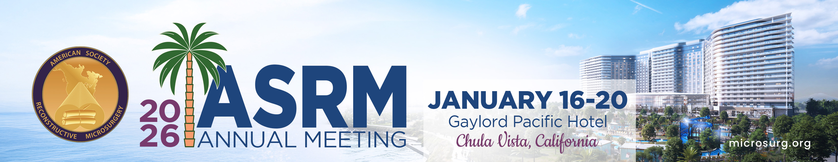

ASRM Abstract Guidelines

Submission Categories
Breast/Lymphedema, Head and Neck, Trauma (i.e. Burn, Extremity, etc), Other (i.e. Basic Science, Gender, CTA, etc)

Submission Guidelines
- Abstracts must be 400 words or less. A maximum of (4) images or tables can be included, but will reduce the allowable word count by 25 for each figure/table.

- The general criteria for consideration of abstracts by the Review Committee are originality, clarity and concise presentation. Research papers will be additionally evaluated for purpose of study, methodology/design, results and conclusions. Multiple entries of the same abstract to more than one program AAHS, ASPN, or ASRM are NOT allowed.

- If your submission has been previously published it will NOT be considered for presentation in any format. If your submission has been previously presented at any national or international meetings it will NOT be considered for presentation. Presentation at state or regional meetings is acceptable.

- No names should be included in the abstract title or text. Nor should the abstract title appear in the text. Names will be automatically hidden from the Review Committee during abstract review and will be automatically inserted and properly formatted upon publication.

- Every author for whom an email address is provided will be automatically informed of the unique ID numbers and passwords assigned to their abstracts. Abstracts may be viewed and modified at any time between submission and the deadline, using the assigned ID# and password.

- The presenting author will be notified of the acceptance status of the abstract(s) via email. Please make sure your e-mail address is current and correct in order to receive continuous notifications relating to your abstract. No other form of notification will be provided

