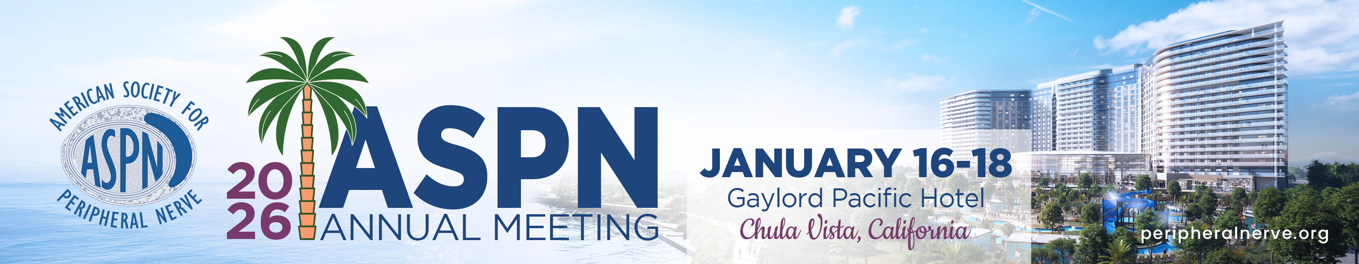
AMERICAN SOCIETY FOR PERIPHERAL NERVE
2026 ANNUAL MEETING ▪ JANUARY 16-18, 2026

▪ SUBMISSION INSTRUCTIONS FOR AUTHORS ▪

Electronic Submission of Abstracts Deadline: Monday, July 7, 2025 @ 11:59 p.m. (CDT)
Technical Support For Abstract Submission: Phone: 401-334-0220
Email: aahsaspnasrm@confex.com
Maximum Word Count: 400
Minimum Word Count: 20

All abstracts for the 2026 ASPN Annual Meeting must be submitted electronically via the official abstract submission website. To submit an abstract, please visit http://peripheralnerve.org/meeting/. Please note that paper abstract submissions will not be accepted.

RULES FOR SUBMISSION OF ABSTRACTS

1.) Abstracts are to be submitted via the official electronic abstract submission website and should be limited to 400 words in length. You must have a minimum of 20 words in the abstract text. There will be a 25-word count penalty for each table and 25-word count penalty for each graph you include in your abstract.

2.) Abstract Format:

Introduction
- Materials & Methods
- Results

Conclusions

3.) The abstract text MUST NOT identify either the authors or institutions from which the work originated. There will be a separate area online in which to indicate all authors, including the presenting author.

4.) Disclosure information must be provided for each author listed in the author block.

5.) The general criteria for consideration of abstracts by the Scientific Program Committees are originality, clarity and concise presentation. Research papers will be additionally evaluated for purpose of study, methodology/design, results and conclusions. Multiple entries of the same abstract to more than one program AAHS, ASPN, or ASRM are NOT allowed.

6.) This year’s ASPN meeting will feature brief 3 minute presentations. All presentations will now be scheduled time for discussion as these brief presentations will be embedded within sessions covering specific topics. The idea is to be inclusive while providing context and promoting discussion.

7.) All abstracts must be completely submitted, and all edits must be made by Monday, July 7, 2025 @ 11:59 p.m. (CDT). Please Note: Submissions and edits are automatically saved. There is no “submit” button. You will not be able to make edits to your abstract after the posted deadline. Faxes and hardcopy abstracts will not be accepted.

8.) The Program Committee for the ASPN will review all abstracts in a blinded format. At that time, they will make their final selections for the 2026 Scientific Program. The presenting author of each abstract will be notified of the decision via email by late August.

9.) The ASPN Executive Council has directed that all presenters must list not only their industry relationships, but the actual dollar amounts for the prior year of public reporting, as reported on openpaymentsdata.cms.gov. This disclosure will be displayed on the first slide of your presentation. The ASPN will provide a template for you to add to your talk no later than 30 days prior to the meeting.

10.) The submitted abstract should not be similar to work submitted to, or under consideration by, other organizations and/or journals

11.) ASPN does not pay for any meeting related cost for presenting authors, including meeting registration, hotel or travel fees.

12.) If you’re abstract is chosen at least one author from the abstract must register and attend the ASPN 2026 Annual Meeting in Chula Vista, California from January 16-18, 2026.

